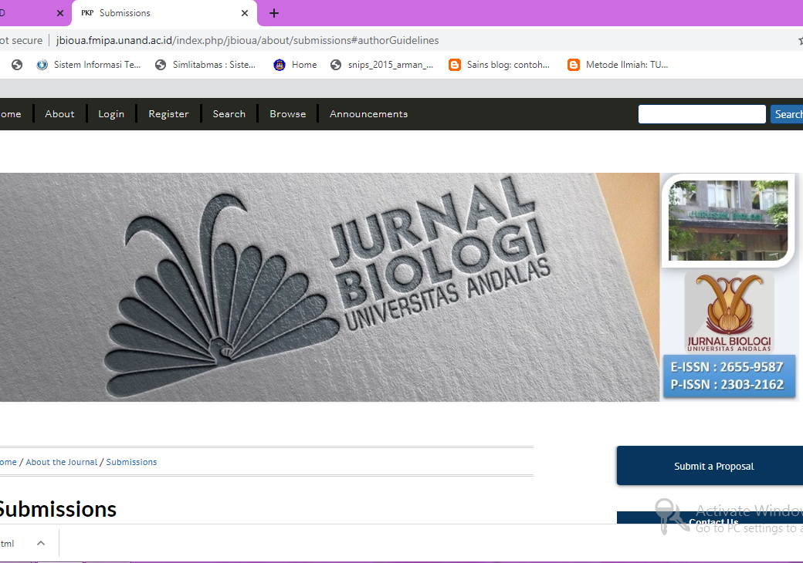

Author Guidelines
MANUSCRIPT WRITING GUIDELINE
Jurnal Biologi Universitas Andalas
Jurnal Biologi Universitas Andalas is a scientific journal that publishes articles regarding various aspects related to biology discipline, including those resulted from student final projects. The manuscript is preferably written in English, or else in Indonesian Bahasa, with bilingual abstracts. Manuscript will be published as soon as it passed the review process.
Manuscript submission
The author is encouraged to send the manuscript through the editor's email at ejurnalbioua@gmail.com. In case that email or internet service is not available at author's end, the softcopy of the manuscript (in tumb or CD drive) can be posted to the address: Jurusan Biologi FMIPA UNAND. Kampus UNAND Limau Manis Padang 25163 (tel. 0751-777427).
Writing Guideline
The maximum length for the manuscript is 10 pages, single space, A4 size
Typed with Microsoft Word or another similar program, double columns (body text, except for title and abstracts), Times New Roman font, 11 pt.
Margin 3 cm (1.2 inches)
Page number positioned on top right
Figure and table are placed accordingly, as well as attached separately along with its pertaining annotation.
Article framework
Initial section, consists of; title, author and co-authors (without any academic salutation), author(s)' address(es) and affiliation, and abstracts. Content section, covers; 1. Introduction, 2. Methodology, 3. Result and discussion, and 4. Conclusion
The closing section, includes; acknowledgment and references
Manuscript Format
Title
Concise (maximum 20 words), bolded (12 pt), each word begun with a capital letter. Scientific names and foreign terms are in italic. The title is written in bilingual.
Author Biodata
Include: full name (with superscript, if needed), affiliation and address of the corresponding author. It the manuscript is synthesized from lecturer's project and/or supervisor, the first author should go to this lecturer/supervisor.
Example:
Keragaman dan Penyebaran Burung Rangkong (Family: Bucerotidae) di dalam Kawasan Hutan Harapan, Jambi
Diversity and Distribution of Hornbills (Family: Bucerotidae) in the Area of Hutan Harapan, Jambi
Jefri Warman1), Wilson Novarino2) dan Jabang Nurdin1)*
1)Laboratorium Ekologi, Jurusan Biologi FMIPA Universitas Andalas
2)Laboratorium Taksonomi Hewan Vertebrata, Jurusan Biologi, FMIPA Universitas Andalas
*Corresponding author: jabangnurdin@fmipa.unand.ac.id
Abstract
The abstract is written in English, no more than 200 words. It contains the summary of background, purpose, methodology, and result of research. Maximum five keywords should be assigned with the abstract, chosen from words or phrases that simply reflect the overall article.
Introduction
The introduction section contains the background of research, supported with a citation on related references related, ended with a paragraph stating the purpose of research.
Research Methodology
Any method used, along with its equipment, should be detailed whenever novel and previously unpublished. The published one will only need its working principle and supported with a citation on related references. The modified method needs to be thoroughly explained its modification, asserted with the previous reference. Data analysis is also detailed.
Result and discussion
Both parts are not separated, discussed inherently using supporting reference. Table and graphics are arranged in an open style. The title for table and figure is numbered accordingly, thus can be referred to in such a manner whenever mentioned in the body text. Important points resulted from the research should be discussed in connection to the formulation of the research problem and hypothesis. Any similarity, difference, and uniqueness of current research should be compared to the current and update the progress of the related subject or topic.
Conclusion
The conclusion is drawn based on the research result, while keeping its connection with the problem and purpose of the research.
Acknowledgment
Author(s) acknowledge the donor and other meritorious parties related to the project or manuscript writing.
Reference
Reference is arranged alphabetically, using the name and year system.
Journal:
Sreekumar, P.G., and M. Balakrishan. 2001. Habitat and Attitude Preferences of Butterflies in Alaram Wildlife Sanctuary, Kerala. Tropical Ecology 42(2): 277-281.
Book::
Fleming, W. A. 1991. Butterflies of West Malaysia and Singapore. 2nd edition. Vinlin Pres Sdn. Bhd. Sripetaling. Kuala Lumpur. Malaysia.
Book Chapter:
Wagner, T. 1999. Arboreal chrysomelid community structure and faunal overlap between different type of forests in Central Africa. In: Cox M. L. (ed.), Advance in Chrysomelidae Biology. Leiden. Backhuys Publisher. P: 247-270.
Abstract:
Almuis, J. O., and D. C. Cunnigham. 1986. Semen Traits of Beefbull Ejaculated Frequently. J. Anim. Sci. 25 : 916 (Abstr.).
Proceeding:
Similar to the Book Chapter, but the name of the seminar/symposium/conference mentioned along with place, date, and page in the proceeding
Pratiwi, P., Suwirmen, M. Idris dan R. Puspita. 2010. Induksi Kalus Andalas (Morus macroura Miq.) yang Toleran Terhadap Cekaman Kekeringan Menggunakan Polietilena Glikol (PEG). Dalam : Zul, S., R. Elvira dan Fitmawati (Eds). Prosiding Semirata PTN Barat Bidang Ilmu MIPA Ke-23. Universitas Riau, Pekanbaru, 10-11 Mei 2010. Pusat Pengembangan Pendidikan Universitas Riau. P: 259-264.
Thesis or Dissertation:
Sutra, N. S. M. 2012. Jenis Kupu-kupu (Rhopalocera) di Tanjung Balai Karimun Kabupaten Karimun, Kepulauan Riau.[Skripsi]. Padang. Universitas Andalas.
Source from internet:
Similar to referring the journal, with addition of web address and access date.
Rutowski, R. L. 1997. When Butterflies Meet. http://www.butterflywebsite.com/articles/showarticle.Cfm?iD=27. 8 Agustus 2002.
Book from institution or agency:
Badan Pusat Statistika. 2000. Survey Pertanian Produksi Tanaman Sayuran dan Buah-buahan. Biro Pusat Statistika. Jakarta.

Submission Preparation Checklist
As part of the submission process, authors are required to check off their submission's compliance with all of the following items, and submissions may be returned to authors that do not adhere to these guidelines.
- The submission has not been previously published, nor is it before another journal for consideration (or an explanation has been provided in Comments to the Editor).
- The submission file is in OpenOffice, Microsoft Word, RTF, or WordPerfect document file format.
- Where available, URLs for the references have been provided.
- The text is single-spaced; uses a 12-point font; employs italics, rather than underlining (except with URL addresses); and all illustrations, figures, and tables are placed within the text at the appropriate points, rather than at the end.
- The text adheres to the stylistic and bibliographic requirements outlined in the Author Guidelines, which is found in About the Journal.
- If submitting to a peer-reviewed section of the journal, the instructions in Ensuring a Blind Review have been followed.

Copyright Notice
Please find the rights and licenses in Jurnal Biologi Universitas Andalas (JBioUA).
1. License
The non-commercial use of the article will be governed by the Creative Commons Attribution license as currently displayed on Creative Commons Attribution-NonCommercial-ShareAlike 4.0 International License.
2. Author’s Warranties
The author warrants that the article is original, written by stated author(s), has not been published before, contains no unlawful statements, does not infringe the rights of others, is subject to copyright that is vested exclusively in the author and free of any third party rights, and that any necessary written permissions to quote from other sources have been obtained by the author(s).
3. User Rights
JBioUA's spirit is to disseminate articles published are as free as possible. Under the Creative Commons license, JBioUA permits users to copy, distribute, display, and perform the work for non-commercial purposes only. Users will also need to attribute authors and JBioUA on distributing works in the journal.
4. Rights of Authors
Authors retain the following rights:
- Copyright, and other proprietary rights relating to the article, such as patent rights,
- The right to use the substance of the article in future own works, including lectures and books,
- The right to reproduce the article for own purposes, provided the copies are not offered for sale,
- The right to self-archive the article,
- the right to enter into separate, additional contractual arrangements for the non-exclusive distribution of the article's published version (e.g., post it to an institutional repository or publish it in a book), with an acknowledgement of its initial publication in this journal (Jurnal Biologi Universitas Andalas).
5. Co-Authorship
If the article was jointly prepared by other authors, they warrant that he/she has been authorized by all co-authors to sign this agreement on their behalf, and agrees to inform his/her co-authors of the terms of this agreement.
6. Royalties
This agreement entitles the author to no royalties or other fees. To such extent as legally permissible, the author waives his or her right to collect royalties relative to the article in respect of any use of the article by JBioUA or its sublicensee.

Privacy Statement
The names and email addresses entered in this journal site will be used exclusively for the stated purposes of this journal and will not be made available for any other purpose or to any other party.
However, due to the advancement and availability of hacking and data mining techniques found over the Internet, JBioUA will not be able to guarantee that other parties will not mine our users' email addresses in any possible ways found over the Internet.

