Title - References written in English

TITLE (NO MORE THAN 16 WORDS)
(Center, Times New Roman 14 Pt, Capitalize first letter)
First Author * ¹, Second Author², Third Author³ (Times New Roman 12 Pt)
^{1, 2} Institution / affiliation; address, city and postal code, telephone / fax
³Department of Biology, Faculty of Science and Technology UIN Sunan Gunung Djati, Bandung 40614 (12 Times New Roman)
e-mail: *1xxxx@xxxx.xxx, 2xxx@xxxx.xxx, 3xxx@xxxx.xxx (Times New Roman 11 Pt)

Abstract. The abstract should be 200 - 300 words, do not contain bibliography, numbers, abbreviations, and abbreviations for measurement unless necessary. The abstract organized in this structure: The opening sentences related to the research background as well as a common problem in research, results and concluding sentences. It should be a single paragraph. (Times New Roman, italics 11 Pt).
Keywords: Maximum of 6 specific words, which can help formulate an index.

INTRODUCTION (Introduction –Time New Roman 12 Pt)
It contain the background and specific scope of the study, as well as its relation to some research that has been done. Provide a description (local name and scientific name) of the organism under study. For the citation that taken from the document that has more than two authors, provide the last name of the first author with "et al"

MATERIALS AND METHODS.
The method section needs to be explained in sufficient detail so that the reviewer can answer some or all of the following questions: (i) Is it an experimental or exploratory research? (ii) Whether the method described sufficiently detailed so that the research can be replicated (iii) If the method based on previous research, explain briefly about the method. If the modifications have been done, provide explanation on the parts of the method that being modified, (iv) The name and number of the sample. Specify the source of the samples, if human materials have been used, it must comply with standard ethics and get approval from the authorities.

RESULTS AND DISCUSSION
Mention the results based on the method used. Do not present the same data in two forms. Do not state references in the results section. The average value must use the standard deviation. All results data must be made in the form of tables or graphs. IMAGES AND TABLES are presented in the end of the Article (after the bibliography). See the table and graph creation criteria below. Discussion of data is compared with several research results that have been reported. At the end of the discussion, give conclusions and future research on a particular topic.
ACKNOWLEDGMENTS
Acknowledgments should start by acknowledging non-author contributions and then should provide information related to funding (institutions, years of contract) and people who provide assistance (The name of the person is written without a title)

REFERENCES
The manuscript is written using the standard citation application (Mendeley / Endnote / Zotero), APA (American Psychological Association) style.
Citing an article written by two authors, last name of both authors must be mentioned. However, for the citation that taken from the document that has more than two authors, provide the last name of the first author with "et al"., For example: Kinasih & Hasby (2015), Cahyanto et al. (2011). A series of references must be presented in ascending date order (Retnoningsih et al., 2005; Indriyanti et al.; 2007, Rahayuningsih, 2010). Different publications with the same author (s) and year are presented separately, as follows 2013a, 2013b. Website, private discussion, and unpublished data must be written and use parentheses. For example: (Takahashi, 2009, personal discussion). Unpublished articles are accepted but must be sent as an attachment to the article. At least 80% of primary references (journal articles) published within last 10 years.

Book with Editor
Arnim, A. G. (2005). Molecular Aproaches to the Study of Plant Development. Dalam: Trigiano RN & Gray DJ. Plant Development and Biotechnology. Washington DC: CRC Press.

Article from the journal
Fagard, R.H. (2002). Epidemiology of Hypertension in Elderly. American Journal of Geriatric Cardiology 11(1) : 23-28.
Seminar / Symposium Articles (in Proceedings)
Partasasmita, R., Suswanti, S & Husodo, T. (2016). Komunitas Burung pada Enam Tipe Ekosistem di Kabupaten Nunukan Kalimantan Timur. Prosiding Seminar Nasional Biologi : Eksplorasi dan Pemanfaatan Biodiversitas untuk menghadapi Ekonomi Masyarakat Asean (MEA). UIN SGD Bandung, 31 Mei 2016. Hlm 97-105.
Article from internet
Hsu, Y. H., & To, K. Y. (2000). Cloning of cDNA (Accesion No AF183891) encoding type II S-adenosyl-L-methionine synthetase from Petunia hybrida. Plant Physiol 122:1457. (PGROO-33). Retrieved from http://www.tarweed.com/pgr/PGROO-033.html.
Thesis/Disertation
Hasby, R. M. (2015). Optimasi Rasio N:P dan Intensitas Cahaya untuk Pertumbuhan dan Akumulasi Lipid Chaetoceros calcitrans. Thesis. Bandung: Sekolah Pascasarjana, Institut Teknologi Bandung.

PICTURE. The maximum figure size is 8.5 cm wide. The number and caption of the figure are written in size 10 Times New Roman.

STATISTIC GRAPHICS. Give a standard deviation for each average value. Authors who use the Microsoft Excel program must provide raw data.
Example Graph:
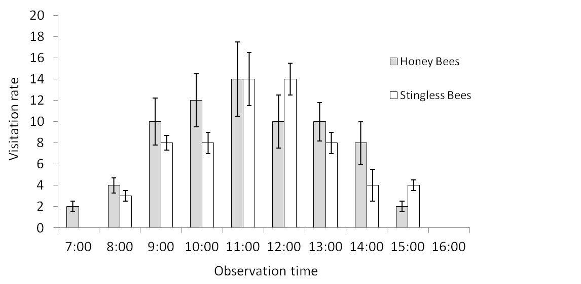
Figure 1. Foraging the activity of Honey Bees and Stingless Bees for 5 minutes per hour across the experiment (in size Time New Roman, 10)

PHOTO. Photo size can be adjusted to your needs. Made professionally with sharp and clear photos. Give an arrow to indicate the main point on the object of observation. If the image / graphic / illustration have been published, citation must be written.
TABLE. Provide a standard deviation for each table. The table title must be short. Additional descriptions for the certain table can be written in the footnotes. If the table has been published, citation must be written. The table and title are written in size 10 Times New Roman.

Table 1. Pollination efficiency (%), average fruit production, weight and diameter produced by insect and wind pollination (N = 50)
Group |  | Honey Bee  (HB) |  | Stingless Bee  (SB) |  | Not Pollinated (NP)
Pollination efficiency (%) |  | 80.3 ± 2.3* |  | 70.2 ± 5.4* |  | 60.3 ± 4.4*
Total fruit production / plant |  | 520.5 ± 5.5 |  | 515.8 ± 6.2 |  | 480.6 ± 7.4*
Fruit weight (gram) |  | 30.05 ±2.5 |  | 27.44 ±8.23 |  | 26.40 ±6.23
Fruit size (diameter in mm) |  | 32.56 ±4.18 |  | 30.19 ±4.16 |  | 27.19 ±3.16
*) significant at P<0.05

